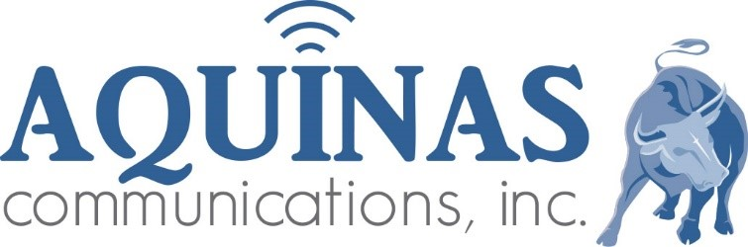 Radio Production Script

Client: FM 98.3 KCRD
Title: Weather Sponsorships by Day
Length: :15
Date: February 23, 2026 – March 20, 2026
Announcer: Jim Vaughn

Intro
The Our Lady of Good Success Radio Network Forecast for Dubuque, Dyersville, & Platteville

………. Forecast………….

Extro
The Our Lady of Good Success Radio Network Forecast is brought to you by

The Christ the King Spiritual Warfare Conference

Register now for the March 21st event
at KCRD-FM.Org or 563-599-2159

__

__

___

___

